 VINOD SIR’S GROUP TUTION

MARKS: 17 MATHS TIME: 1 HOUR

Q. 1: Draw the following: [4]
1. Points 2. Line Segments and Lines
3. Rays 4. Parallel Lines
Q. 2: 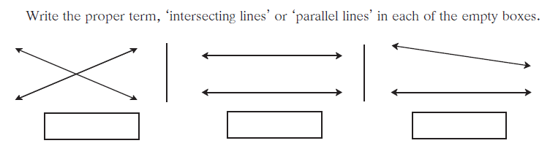 [3]
Q. 3: 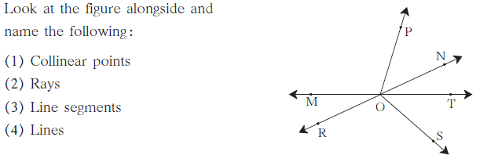 [4]
Q. 4: 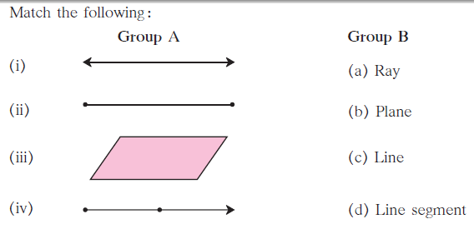 [4]
Q. 5: 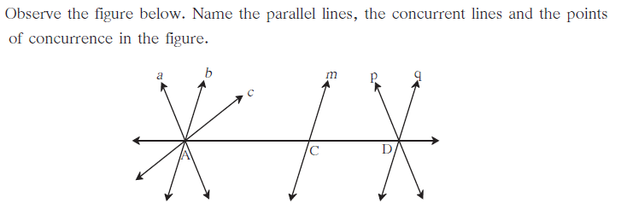 [2]

